- INTRODUCTION
  - Description
A web browser is a software application for retrieving, presenting, and traversing information resources on the World Wide Web. An information resource is identified by a Uniform Resource Identifier (URI) and may be a web page, image, video, or other piece of content. Hyperlinks present in resources enable users easily to navigate their browsers to related resources.
In our project we are going to develop a Web-browser which will support Speech Recognition. This project is useful for those who have disabilities in typing and for those who face problems during web surfing. In this project we are going to focus on the method to develop prototype speech recognition by using Vb.net, a technology such an agent is implemented in the way for solving about the speech recognition.
A voice browser is a web browser with the following capabilities:
    - Can interpret spoken input for navigation (speech recognition)
    - Can interpret spoken input to perform various task related to web browser.
- This paper reviews the topic of voice recognizing web-browser. Voice recognition is a process that recognizes our human voice to produce sentence of word or commands.
- The output of voice recognition systems can be applied in various fields. Therefore, it will be implement in this project by expand a web browser with speech recognition.
- Vb.net provides necessary environment and libraries for voice recognition.
System, auto-contrasting, and finally image sharing application, we envision a teleconferencing tool that can support the needs of today’s designers.

1.2 Motivation

In this project voice recognition can be done using Microsoft Speech SDK i.e. SAPI (Speech Application Programming Interface) which is consisting of Hidden Markov Model for accurate grammer proccessing .We have chosen Microsoft Speech for detection of voice command spoken by user.
The purpose of this project is to develop a Web browser that allows user to navigate by speaking the text of a link or an associated number instead of clicking with a mouse.
Our project is useful to those people who have difficulty in accessing the World Wide Web, and those who temporarily cannot use a existing web browser (for example, because their eyes or hands are occupied or because they are not near their computer).
Nowadays, most of the web browsers don’t support speech recognition. For those who are disabilities in typing will facing problem during the web surfing. In this project we will focus on the method to develop prototype speech recognition by using Vb.net, a technology such an agent is implemented in the way for solving about the speech recognition.

1.3 Relevance of the Project
- The system allows processing of Voice of the one person at a time; however the more than one person Voice leads to improper output.
- Speech Clarity - The speech clarity of user should be good for precise command detection.
- Capturing Voice through the microphone – It is better to capture the voice command through the microphone than desktop mike for perfect capturing of the voice.
- The Noiseless operating environment – For better output and working of the system there should not be more noise in the environment

1.4 Scope of the Project
A web browser is a software application for retrieving, presenting, and traversing information resources on the World Wide Web. An information resource is identified by a Uniform Resource Identifier (URI) and may be a web page, image, video, or other piece of content. Hyperlinks present in resources enable users easily to navigate their browsers to related resources.
Speech recognition is a process that recognizes our human voice and converts it into text or commands that would perform a specific task. The output of voice recognition systems can be applied in various fields. Therefore, it will be implemented in this project by introducing a web browser with speech recognition.
Voice operated web browser is designed especially for a disabled person. The design of such web browser needs to consider many technical constraints, disabilities and wishes of the future.
This web browser will have the ability to search, navigate web-pages on World Wide Web from a PC through speech input i.e. the user will exercise control over the web browsing through voice.
Information contained on the World Wide Web is inaccessible to many people. The web is primarily a visual medium that requires a keyboard and mouse to navigate, and this disenfranchises several types of users.

1.5 Objectives of the Project
The goal of this project is to develop a Web browser that allows user to navigate by speaking the text of a link or an associated number instead of clicking with a mouse.
Our project is useful to those people who have difficulty in accessing the World Wide Web, and those who temporarily cannot use a existing web browser (for example, because their eyes or hands are occupied or because they are not near their computer).
Nowadays, most of the web browsers don’t support speech recognition. For those who are disabilities in typing will facing problem during the web surfing. In this project we will focus on the method to develop prototype speech recognition by using Vb.net, a technology such an agent is implemented in the way for solving about the speech recognition.

2. REVIEW OF LITERATURE
Speech Recognition is technology that can translate spoken words into text. Some SR systems use "training" where an individual speaker reads sections of text into the SR system. These systems analyze the person's specific voice and use it to fine tune the recognition of that person's speech, resulting in more accurate transcription.
Basically, the microphone converts the voice to an analog signal. This is processed by the sound card in the computer, which takes the signal to the digital stage. Input from user is also known as utterance (Spoken input from the user of a speech application. An utterance may be a single word, an entire phrase, a sentence, or even several sentences.)This is the binary form of ―1s‖ and ―0s‖ that make up computer programming languages. Computers don’t ―hear‖ sounds in any other way. Sound-recognition software has acoustic models (An acoustic model is created by taking audio recordings of speech, and their text transcriptions, and using software to create statistical representations of the sounds that make up each word. It is used by a speech recognition engine to recognize speech) convert the voice sounds to one of about four dozen basic speech elements (called phonemes). The latest versions of speech technology have been refined so that they eliminate the noise and useless information that is not needed to let the computer work. The words we speak are transformed into digital forms of the basic speech elements (phonemes).
Once this is complete, a second sector of the software begins to work. The language is compared to the digital ―dictionary‖ that is stored in computer memory. This is a large collection of words, usually more than 100,000. When it finds a match based on the digital form it displays the words on the screen. This is the basic process for all speech recognition systems and software. [1]
Both acoustic modelling and language modelling are important parts of modern statistically-based speech recognition algorithms. Hidden Markov models (HMMs) are widely used in many systems. Language modelling has many other applications such as smart keyboard and document classification.[1]
The model is denoted by (A, B, ), where A is the set of observables, B is the set of hidden states, and is the set of transition probabilities, i.e., the probabilities from going to one hidden state to another. This model is known as double stochastic since there is a hidden layer that contains some hidden states. This
Hidden layer follows the principles of Markov process. The other layer contains the states of the observables in a particular time t of the model construction. This is also a Markov process where the observable outputs can be seen, unlike the hidden layer. [2]
The HMM algorithm works in two steps. The HMM is trained in the first step using the training sequences. At the initial state (at time t0), the state transition probabilities and the observable output probabilities are randomly assigned. However, assigning these probabilities according to prior knowledge of the system, instead of the random assignment, can improve the performance of HMM. At this point, the model is denoted with 0. Then, applying the Baum-Welch algorithm, the HMM 0 is adjusted according to the input training sequences and construct the new model 1. After every adjustment of , the probability difference of the previous model and the adjusted model is calculated. [1]
If the difference is below the preset probability difference threshold, the model is known to be the final HMM. Otherwise, further adjustment is required. In the next step, the unknown sequences are applied to the model and the likelihood of the sequences (i. e., the probability of how much a sequence conforms the HMM) are determined. If the probability is above the predefined acceptable probability, the sequence is concluded as a non-anomalous sequence. Otherwise, it is concluded as an anomalous one. The HMM algorithm has very accurate prediction of anomaly and has been used for complex sequence analysis. However, the model training time is very high in HMM algorithm. [2]
The Voice Driven Interface essentially accepts spoken words as input. The input signals are then compared against with a set of pre-defined commands. If there is an appropriate match, the corresponding command is output to the Command Processor.
The engine also handles auxiliary functions (in conjunction with the speech synthesis engine) such as the confirmation of commands where appropriate, speed control and the URL dictation system. The Text-to-Speech/audio engine is responsible for producing the only output from the system back to the user. The output is in the form of spoken (synthesised) text, or sounds for the auditory icons. [3]
The input for these two engines comes from the Command Processor. The input can either be a text stream consisting of the actual information to be read out as the content of the page (processed by the TTS engine), or an instruction to play a sound as an auditory icon to mark a document structure [3].
Voice recognition- It was one of the more poorly rated criteria. While both groups considered it a necessary technology for the idea of a phone browser, subjects suffered from its shortcomings, and it did result in a loss of efficiency for most users. Subjects from G2 responded more favourably than those from G1. Of particular concern was the dictation of URL addresses [5]. This was noted as a shortcoming in the interface by every user from both groups. The idea of having to spell out URL addresses one letter at a time (and wait for confirmation of each letter) was not well received. The idea of using shortcuts like ‘company’ to spell out ‘.com’ was considered a strong improvement, thus this technique must be further explored.[4]

3. SYSTEM SYUDY AND ANALYSIS
3.1 Existing System
Speech recognition has been for-fronted much over years now, although the technology still requires training to reduce the error margin. Up until now, mainly dictation software and software for disabled people made use of speech recognition, but the most recent advances have brought speech recognition to the brink of becoming an established technology in the mass market. With various Operating System bundling speech recognition and biometrics techniques, the way PC’s are used had taken much step ahead.
Since OS like windows / Mac introduced Speech Recognition technology, developers began to concentrate much on this technology. Now a day many Smartphone’s offers speech recognition capabilities.
Browsing web with Speech Recognition
With Windows Speech Recognition, browsing the Internet means figuring out what the objects in the web browser window are called and then saying the commands you need to interact with them. You could easily activate browsing feature through various voice commands. For browsers like Firefox, Firesay is an interesting add-on for Firefox, as it adds speech recognition to the web browser so that users can use voice commands to issue commands in the browser.
What Chrome Offers???
Google Chrome too has added the potential for voice recognition to the beta version of its Chrome browser in the latest update to the software.The tool works through the newly-included HTML5 speech input API and once implemented would give users the ability to add text to any input area on a website without touching the keyboard. Google said that once recorded, the audio would be sent to Google’s specialist speech servers for transcription, before being sent back to the original computer and typed into the text box
The move comes as Google continues to expand its voice recognition services from portable devices onto the desktop. Already introduced technology -Google Voice Search (www.google.com/mobile/voice-search/) is one of the most prominent apps on the mobile side, and is available across the Android, BlackBerry, iOS, Nokia S60 and Windows platforms.

Using Opera with your voice
Opera Software has announced a voice-activated browser. The new browser, launch date not yet announced, incorporates IBM’s ViaVoice software and will respond to voice commands from the user.

3.2 Proposed System
This project has the speech recognizing and speech synthesizing capabilities though it is not a complete replacement of what we call a WEB BROWSER but still a good web browser to be used through voice. This software also can search web pages and perform tasks related to web browser.
This project also includes a voice mark feature which is very much similar to the book mark feature that is available in the existing web-browser. The following are the main modules which are supposed to be implemented in our project: -
  - Tab Control – By speaking ‘New Tab’ Command user can open the new tab in explorer and can open new website in newly opened tab.
  - Search Provider - By speaking ‘Search’ Command search bar will be activated and user can search for the content from already saved websites like google, yahoo, Wikipedia etc.
  - Working with favorites – Your favorite links can be saved using favorite option of this explorer.
  - Implementation of Voice-Mark feature – By speaking ‘voice mark’ command user can save frequently used websites address with some short name. This feature is like a bookmark feature of explorer.

  - Working with History and Cookies – user of the system can open the history window to go to the websites opened some day before.
  - Simple RSS (Really Simple Syndication) reader – Live updates and post can be read using RSS reader.

  - Requirement Analysis
- Safety Requirements
Highly recommend Kaspersky 2010 internet security to be installed in users PC to prevent harm that may occurs by unwanted malicious softwares’s phishing URLs and all types of virus attacks during using the application.
- Security Requirements
All users should be properly authenticated before allowed entry into the system authentication will be based on an E-mail address, and a password.
All activities on the system must be logged.
- Non-Functional Requirements
Secure access of confidential data(user’s details).SSL can be used.
24x7 availability.
Better component design to get better performance at peak time.
Flexible service based architecture will be highly desirable for future extension
- Other Requirements
The usermust be agreed with all the terms and conditions that have provided by the system administrator ,local authority and should obey to all international standards and protocols.

3.4 Use Case Diagrams and Descriptions
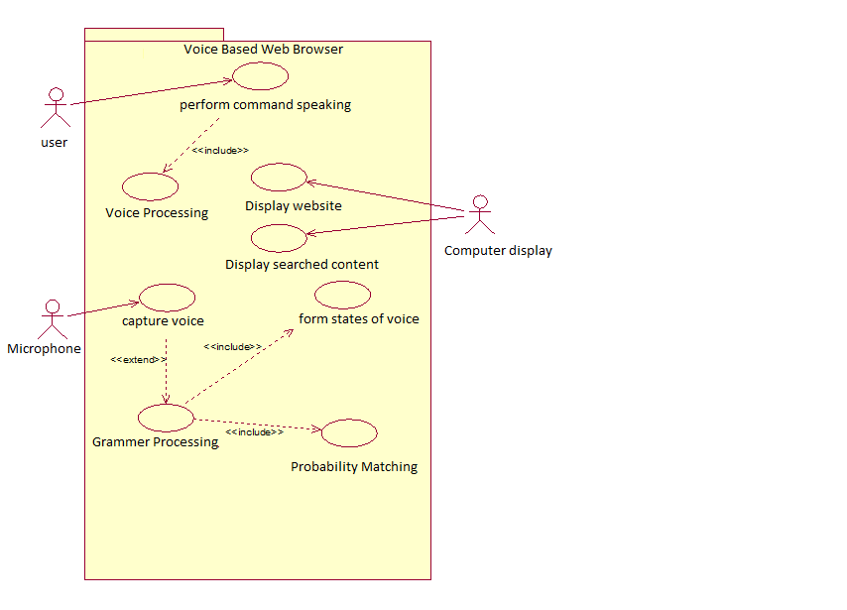
Fig. 3.1 Use case diagram for system

Table 3.1 Use case description for user actor

Use case Name: | Perform command speaking
Actors: | User
Precondition: | The user determines which command to be spoken.
Post condition: | The user speaks a voice command.
Scenario: | - The user thinks the voice command to speak.  - Then the system captures it.

Table 3.2 Use case description for Microphone actor

Usecase name: | Capture Voice
Actors: | Microphone
Precondition: | Microphone must be properly connected.
Post condition: | The system checks whether the proper voice is captured.
Scenario: | - Capture voice through Microphone.  - The system processes.

4. ANALYSIS MODELING
4.1 Data Dictionary

Table 4.1 Data Dictionary for Jarvis Browser

Field Name | Description | DataType | Integrity Constraints
Input Voice | Voice is to be converted in to Text | .wav | Not Null
Display Result | Display the input voice in the form of Text | String | Not Null
Perform Operation | Do operations on Retrieved File | String | Not Null

4.2 Class Diagrams
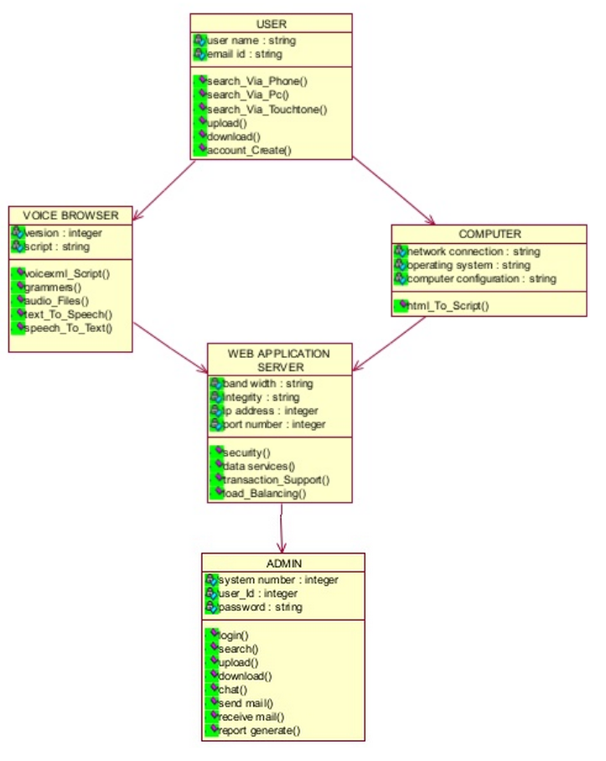
Fig. 4.1 Class Diagram for project

4.3 Functional Modeling
The design details of voice based web browser is represented with the help of Data Flow Diagrams (DFD’s) is shown below. In this system we have computed DFD’s up to Level 2 in which we have represented the detailed flow of the proposed project starting from the initial input from the microphone till the final output.

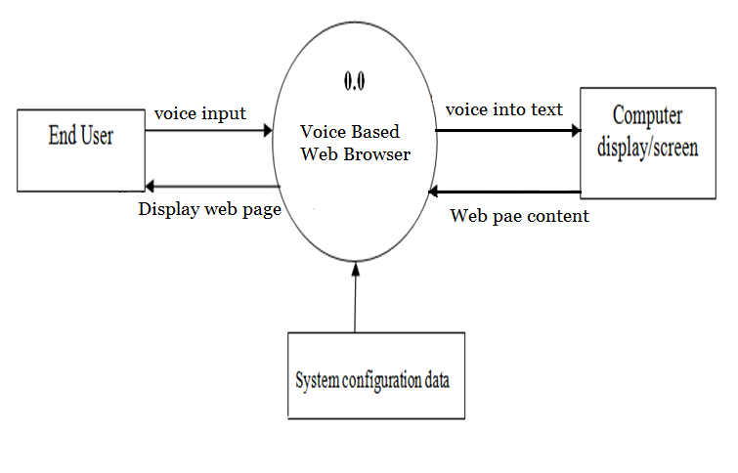
Fig. 4.2 Level 0 DFD

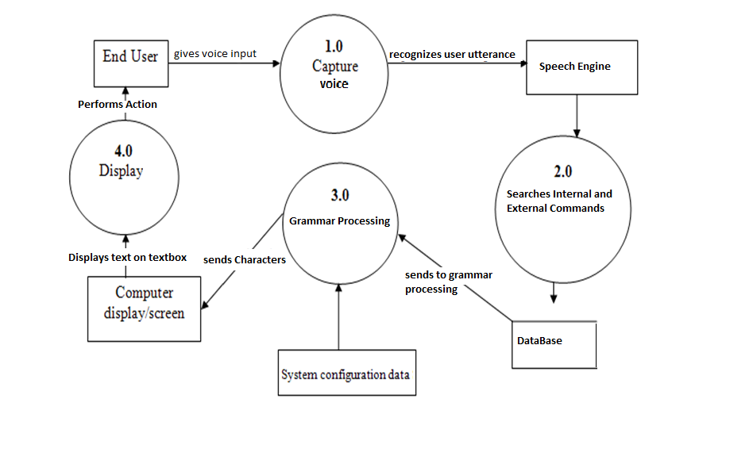

Fig. 4.3 Level 1 DFD

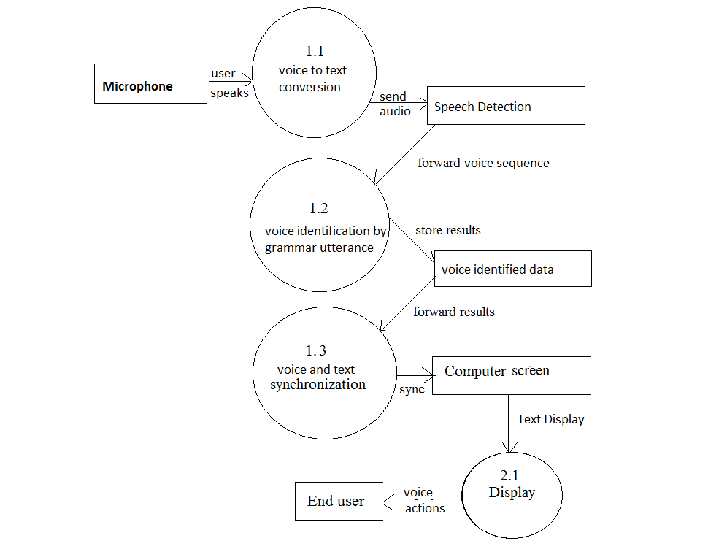

Fig. 4.4 Level 2 DFD

4.4 Timeline Chart
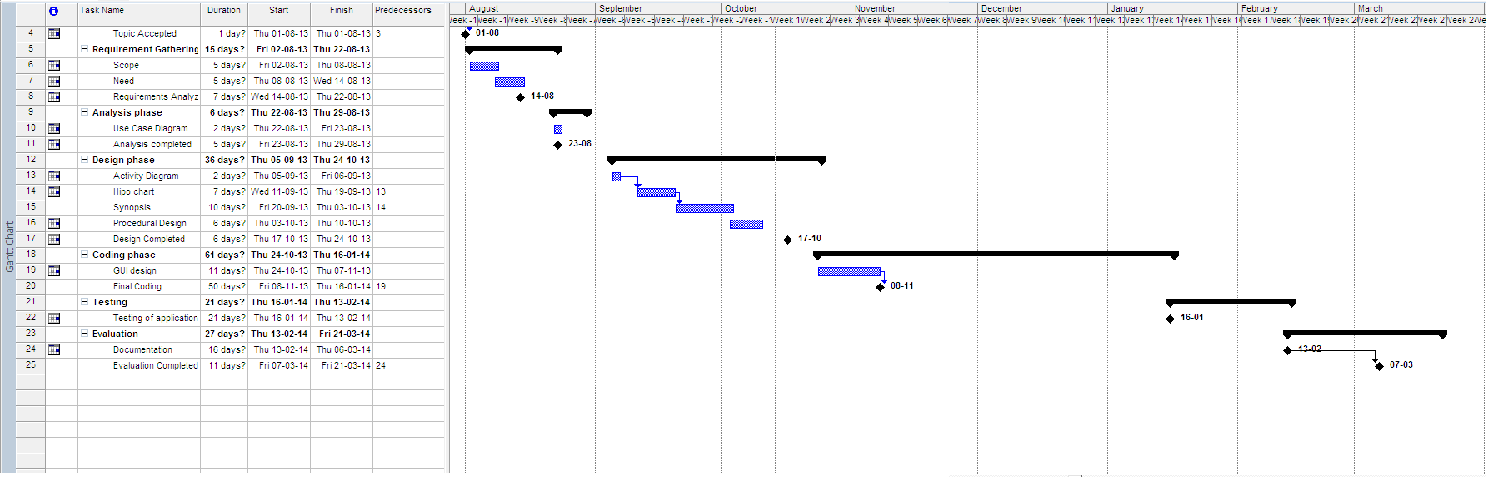

Fig. 4.5 Timeline chart

5. DESIGN
5.1 Architectural Design

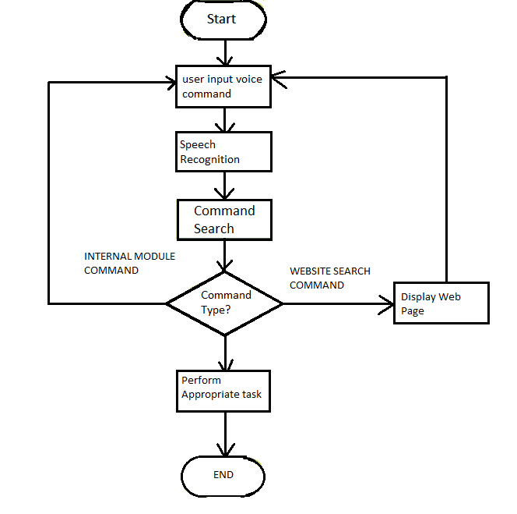

Fig.5.1 Architectural Design of project

  - User Interface Design


Fig.5.2 UI Design of Address Bar

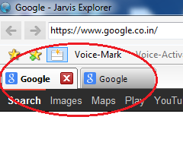

Fig.5.3 UI Design of Tab Control

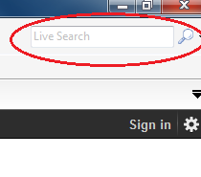
Fig.5.4 UI Design of Search Provider

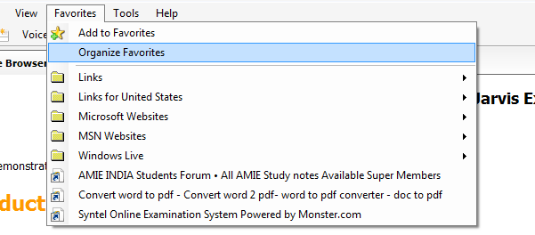
Fig 5.5 UI Design of Working with Favorites

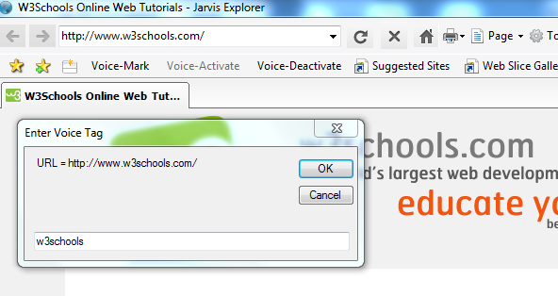
Fig 5.6 UI Design of Voice Mark Feature

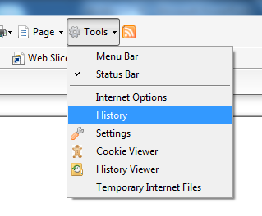
Fig 5.7 UI Design of History and cookies

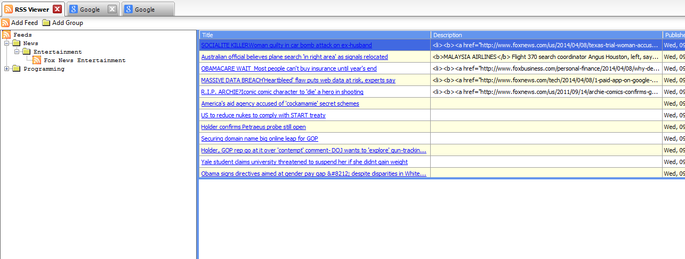
Fig 5.8 UI Design of RSS Reader

6. IMPLEMENTATION
  - Hardware and Software Used

Front-End:- VB.net
Back-End:- Database using File Handling and XML
(i) VB.net:-
Visual Basic .NET (VB.NET) is an object-oriented computer programming language that can be viewed as an evolution of the classic Visual Basic (VB), which is implemented on the .NET Framework. Microsoft currently supplies two major implementations of Visual Basic: Microsoft Visual Studio, which is commercial software and Microsoft Visual Studio Express, which is free of charge. Microsoft implementation of Visual Basic .NET is called "Microsoft Visual Basic".
(ii) Database using File Handling and XML:-
VB.NET File Handling
With the File style in the .NET Framework, you can perform efficient and simple manipulations of files, including reads, writes, and appends. Using a set of examples, we look at how you can programmatically test and mutate files in the VB.NET language.
Here, we describe in brief many of the methods available in the VB.NET language and .NET framework on the File type. Some methods have been omitted; also the System.IO namespace provides many other types that are separate from these shared methods.
File.ReadAllBytes: Useful for files not stored as plain text. You can open images or movies with this method.
File.ReadAllLines: Microsoft: "Opens a file, reads all lines of the file with the specified encoding, and closes the file."
File.ReadAllText: Returns the contents of the text file at the specified path as a string.Very useful for plain text or settings files.
File.WriteAllBytes: Useful for files such as images that were created or mutated in memory.
File.WriteAllLines: Stores a string array in the specified file, overwriting the contents.Shown in an example below.
File.WriteAllText: Writes the contents of a string to a text file.One of the simplest ways to persist text data.
File.AppendAllText: Use to append the contents string to the file at path. Microsoft: "Appends the specified string to the file, creating the file if it doesn't already exist."

XML
XML is a markup language for documents containing structured information.
Structured information contains both content (words, pictures, etc.) and some indication of what role that content plays (for example, content in a section heading has a different meaning from content in a footnote, which means something different than content in a figure caption or content in a database table, etc.). Almost all documents have some structure.
A markup language is a mechanism to identify structures in a document. The XML specification defines a standard way to add markup to documents.
Data is usually best stored in a structured format. In cases where a database is not necessary, you can use XML files. With XmlReader and XmlWriter in the VB.NET language, you can read and write XML in an efficient way.

Hardware Used : -

Microphone:
A quality microphone is the key when utilizing the speech recognition system. Desktop microphones are not suitable to continue with speech recognition system, because they have tendency to pick up more ambient noise.
The best choice, and most common is the headset style. It allows the ambient noise to be minimized, while allowing you to have the microphone at the tip of your tongue all the time. Headsets are available without earphones and with earphones (mono or stereo).

Computer/ Processors:
Speech recognition applications can be heavily dependent on processing speed. This is because continuous voice recognition can take place. Thus to avoid unnecessary delays a processor having good processing capability is required

6.2 Algorithms / Methods Used
The main idea behind the project is to get the voice input from user through devices like microphone to control the web browser. The web browser control is done by the means of human speech input. The different speech utterance are made to performed various browser actions..

Algorithm for Speech Detection:
- Capture Voice:
In this step the voice is captured from the microphone.

- Voice to sequence of observation sequence:
In this step the continuous voice stream is converted to sequence of states for further processing.

- Process states:
In this step each state is processed to match state with existing states.

- Voice Detection:
In this step the Text is detected. This is the main part of the algorithm and overall system functioning.

- Text Display Movement:
In this step Text is displayed on Screen according to the states matching with highest probability with existing states.

- Microphone On/Off:
We can control the web browser till the microphone is on.

6.3 Working of the project
// frmAddRSS.vb
Imports System.Data.OleDb

Public Class frmAddRSS
Public GroupID As Integer
Public RSSForm As frmRSS
Enum Modes
AddFeed
AddGroup
End Enum
Private _mode As Modes
Public Property Mode() As Modes
Get
Return _mode
End Get
Set(ByVal value As Modes)
_mode = value
End Set
End Property

Private Sub btnCancel_Click(ByVal sender As System.Object, ByVal e As System.EventArgs) Handles btnCancel.Click
Me.Close()
End Sub

Private Sub LoadFromDB()
Dim strSQL As String = "SELECT * FROM RSSGROUPS"
Dim oConn As New OleDbConnection(AppManager.ConnString)
Dim oDa As New OleDbDataAdapter(strSQL, oConn)
Dim dt As New DataTable
Dim dr As DataRow
Dim li As ListItem

Try

oDa.Fill(dt)

For Each dr In dt.Rows
li = New ListItem
If dr.Item("ParentID") = 0 Then
li.Text = dr.Item("GroupTitle")
li.Value = dr.Item("ID")
cboGroups.Items.Add(li)
GetChildren(li.Value, dt)
End If
Next

Catch ex As Exception
Dim ofrm As New frmError
ofrm.err = ex
ofrm.ShowDialog()
End Try
End Sub

Private Sub GetChildren(ByVal itmID As Integer, ByVal dt As DataTable)
Dim dv As New DataView(dt)
dv.RowFilter = "parentID=" & Integer.Parse(itmID)
Dim row As DataRowView
Dim itm As ListItem
Try
For Each row In dv
' Perform the node addition
itm = New ListItem
itm.Text = row("GroupTitle")
itm.Value = row("ID")
cboGroups.Items.Add(itm)
Next
Catch ex As Exception
Dim ofrm As New frmError
ofrm.err = ex
If Not IsNothing(Me.Parent) Then
ofrm.ShowDialog(Me.Parent)
Else
ofrm.ShowDialog(Me)
End If
End Try
End Sub

Private Sub frmAddRSS_Load(ByVal sender As System.Object, ByVal e As System.EventArgs) Handles MyBase.Load
If Me.Mode = Modes.AddGroup Then
txtURL.Enabled = False
Dim li As New ListItem
li.Text = "Top level"
li.Value = 0
cboGroups.Items.Add(li)
End If
LoadFromDB()
cboGroups.SelectedIndex = 0
End Sub

Private Sub btnAdd_Click(ByVal sender As System.Object, ByVal e As System.EventArgs) Handles btnAdd.Click
Select Case Me.Mode
Case Modes.AddFeed
If txtTitle.Text = "" Then
MsgBox("Please enter a Title.")
Exit Sub
End If
If txtURL.Text = "" Then
MsgBox("Please enter a URL.")
Exit Sub
End If
If IsNothing(cboGroups.SelectedItem) Then
MsgBox("Please select a group.")
Exit Sub
End If
AddFeed()
Case Modes.AddGroup
If IsNothing(cboGroups.SelectedItem) Then
MsgBox("Please select a group.")
Exit Sub
End If
If txtTitle.Text = "" Then
MsgBox("Please enter a Title.")
Exit Sub
End If
AddGroup()
End Select
End Sub

Private Sub AddFeed()
Dim li As ListItem = cboGroups.SelectedItem
Dim strSQL As String = "INSERT INTO RSSChannels (GroupID, ChannelTitle, Link) VALUES ('" & _
CInt(li.Value) & "', '" & txtTitle.Text & "', '" & txtURL.Text & "')"
Dim oConn As New OleDbConnection(AppManager.ConnString)
Dim oCmd As New OleDbCommand(strSQL, oConn)
Try
oConn.Open()
oCmd.ExecuteNonQuery()
oConn.Close()
If Not IsNothing(Me.RSSForm) Then
Me.RSSForm.LoadFromDB()
End If
Me.Close()
Catch ex As Exception
Dim ofrm As New frmError
ofrm.err = ex
ofrm.ShowDialog(Me)
Finally
oConn.Dispose()
oCmd.Dispose()
End Try
End Sub

Private Sub AddGroup()
Dim li As ListItem = cboGroups.SelectedItem
Dim strSQL As String = "INSERT INTO RSSGroups (ParentID, GroupTitle) VALUES ('" & _
CInt(li.Value) & "', '" & txtTitle.Text & "')"
Dim oConn As New OleDbConnection(AppManager.ConnString)
Dim oCmd As New OleDbCommand(strSQL, oConn)
Try
oConn.Open()
oCmd.ExecuteNonQuery()
oConn.Close()
Me.RSSForm.LoadFromDB()
Me.Close()
Catch ex As Exception
MsgBox(ex.Message.ToString)
Finally
oConn.Dispose()
oCmd.Dispose()
End Try
End Sub

Private Sub cboGroups_SelectedIndexChanged(ByVal sender As System.Object, ByVal e As System.EventArgs) Handles cboGroups.SelectedIndexChanged

End Sub
End Class

// frmHistory.vb
Public Class frmHistory

Enum LoadModes
History = 2097153
Cache = 0
End Enum

Public LoadMode As LoadModes = LoadModes.History 'Default

Public Sub fillday2()
Dim i As Object
On Error GoTo rt

Dim sdate As Date
sdate = DateAdd(DateInterval.Day, -1, Today)

For i = 0 To 30

sdate = DateAdd(DateInterval.Day, -i, Today)
cmbDay.Items.Add(CStr(sdate))
Next i

Exit Sub
rt:
MsgBox(ErrorToString())
Resume rte
rte:

End Sub

Private Sub frmHistory_Load(ByVal sender As System.Object, ByVal e As System.EventArgs) Handles MyBase.Load
Dim mtdate As Object
Dim xk As Object
Dim fdate As Object
fillday2()
fdate = cmbDay.Text

If IsDate(fdate) = False Then GoTo mm
xk = Weekday(fdate, FirstDayOfWeek.Sunday)
Select Case xk
Case 1

mtdate = "Monday"
Case 2

mtdate = "Sunday"
Case 3

mtdate = "Tuesday"
Case 4

mtdate = "Wenesday"
Case 5

mtdate = "Thursday"
Case 6

mtdate = "Friday"
Case 7

mtdate = "Saturday"
End Select
mm:

ListView1.Columns.Add("Item name", 350, HorizontalAlignment.Left)
ListView1.Columns.Add("Last access date", 150, HorizontalAlignment.Left)
ListView1.Columns.Add("hitrate", 50, HorizontalAlignment.Left)
ListView1.Columns.Add("last modiefied date", 100, HorizontalAlignment.Left)
ListView1.Columns.Add("last syntime", 100, HorizontalAlignment.Left)
ListView1.Columns.Add("usecount", 50, HorizontalAlignment.Left)
ListView1.Columns.Add("local file name", 300, HorizontalAlignment.Left)
ListView1.Columns.Add("File extension", 150, HorizontalAlignment.Left)
ListView1.Columns.Add("Fiel header info", 150, HorizontalAlignment.Left)
ListView1.Columns.Add("File type", 100, HorizontalAlignment.Left)
cmbDay.SelectedIndex = 0
getcachentry(LoadMode)
End Sub

Private Sub getcachentry(ByVal type As String)
Dim x As Object
Dim sdate As Date

If IsDate(cmbDay.Text) Then
sdate = DateValue(cmbDay.Text)
Else
MsgBox("No valid date choosen)")
End If
sdate = Format(sdate, "short date")
x = GetURLCache(ListView1, sdate, type)
End Sub

Private Sub cmbDay_SelectedIndexChanged(ByVal sender As Object, ByVal e As System.EventArgs) Handles cmbDay.SelectedIndexChanged
Dim mtdate As Object
Dim xk As Object
Dim fdate As Object
Dim sdate As Date

fdate = cmbDay.Text

If IsDate(fdate) = False Then Exit Sub
xk = Weekday(fdate, FirstDayOfWeek.Sunday)
Select Case xk
Case 1

mtdate = "Monday"
Case 2

mtdate = "Sunday"
Case 3

mtdate = "Tuesday"
Case 4

mtdate = "Wenesday"
Case 5

mtdate = "Thursday"
Case 6

mtdate = "Friday"
Case 7

mtdate = "Saturday"
End Select

sdate = DateValue(cmbDay.Text)

getcachentry(LoadMode)
End Sub

Private Sub cmbDay_TextChanged(ByVal sender As Object, ByVal e As System.EventArgs) Handles cmbDay.TextChanged

End Sub

Private Sub cmbDay_Click(ByVal sender As System.Object, ByVal e As System.EventArgs) Handles cmbDay.Click

End Sub

Private Sub ListView1_MouseDoubleClick(ByVal sender As Object, ByVal e As System.Windows.Forms.MouseEventArgs) Handles ListView1.MouseDoubleClick
Dim strURL As String
If ListView1.SelectedIndices.Count > 0 Then
Dim li As ListViewItem = ListView1.SelectedItems(0)
Select Case Me.LoadMode
Case LoadModes.Cache
strURL = li.Text
Case LoadModes.History
Dim s() As String = Split(li.Text, "@")
strURL = s(1)
End Select

Dim ofrm As frmBrowser
Dim i As Integer
For i = 0 To AppManager.MainForm.tc1.TabPages.Count - 1
If TypeOf AppManager.MainForm.tc1.TabPages(i).Form Is frmBrowser Then
ofrm = AppManager.MainForm.tc1.TabPages(i).Form
If ofrm.wb Is AppManager.CurrentBrowser Then
AppManager.CurrentBrowser.Navigate(strURL)
AppManager.MainForm.tc1.TabPages(i).Select()
Exit Sub
End If
End If
Next
End If
End Sub
End Class

// frmDownload.vb
Public Class frmDownload
Public DLURL As String

Private Sub frmDownload_Load(ByVal sender As System.Object, ByVal e As System.EventArgs) Handles MyBase.Load
Me.lblInfo.Text = "Confirm download of file: " & _
DLURL
End Sub

Private Sub btnCancel_Click(ByVal sender As System.Object, ByVal e As System.EventArgs) Handles btnCancel.Click
Me.Close()
End Sub

Private Sub btnOK_Click(ByVal sender As System.Object, ByVal e As System.EventArgs) Handles btnOK.Click
Me.Close()
End Sub
End Class

// frmCookieViewer.vb
Imports System.IO
Public Class frmCookieViewer
Private SelNode As TreeNode

Private Sub frmCookieViewer_Load(ByVal sender As System.Object, ByVal e As System.EventArgs) Handles MyBase.Load
LoadCookies()
End Sub

Private Sub LoadCookies()
tvCookies.Nodes.Clear()
Dim s As String
Dim oNode As TreeNode
Dim oInfo As FileInfo
For Each s In Directory.GetFiles(Environment.GetFolderPath(Environment.SpecialFolder.Cookies))
If s.EndsWith(".txt") Then
oInfo = New FileInfo(s)
oNode = New TreeNode
oNode.Text = oInfo.Name
oNode.Tag = s
oNode.ImageIndex = 0
oNode.SelectedImageIndex = 0
tvCookies.Nodes.Add(oNode)
End If
Next
End Sub

Private Sub ViewCookie(ByVal oNode As TreeNode)
Try
rtbCookies.LoadFile(oNode.Tag, RichTextBoxStreamType.PlainText)
Catch ex As Exception
Dim ofrm As New frmError
ofrm.err = ex
ofrm.ShowDialog(AppManager.MainForm)
End Try
End Sub

Private Sub tvCookies_AfterSelect(ByVal sender As Object, ByVal e As System.Windows.Forms.TreeViewEventArgs) Handles tvCookies.AfterSelect
SelNode = e.Node
btnDelete.Enabled = True
End Sub

Private Sub tvCookies_Click(ByVal sender As Object, ByVal e As System.EventArgs) Handles tvCookies.Click
If Not IsNothing(SelNode) Then
cmCookies.Enabled = True
Else
cmCookies.Enabled = False
End If
End Sub

Private Sub tvCookies_NodeMouseClick(ByVal sender As Object, ByVal e As System.Windows.Forms.TreeNodeMouseClickEventArgs) Handles tvCookies.NodeMouseClick
If e.Button = Windows.Forms.MouseButtons.Left Then
ViewCookie(e.Node)
Else
tvCookies.SelectedNode = e.Node
End If
End Sub

Private Sub mnuDeleteCookie_Click(ByVal sender As System.Object, ByVal e As System.EventArgs) Handles mnuDeleteCookie.Click
DeleteCookie()
End Sub

Private Sub DeleteCookie()
Try
If Not IsNothing(SelNode) Then
If MessageBox.Show("Are you sure you want to delete cookie" & tvCookies.SelectedNode.Text & "?", "Confirm Delete", MessageBoxButtons.YesNoCancel) = Windows.Forms.DialogResult.Yes Then
File.Delete(SelNode.Tag)
tvCookies.SelectedNode.Remove()
End If
End If
Catch ex As Exception
Dim ofrm As New frmError
ofrm.err = ex
ofrm.ShowDialog(AppManager.MainForm)
End Try
End Sub

Private Sub btnDeleteALL_Click(ByVal sender As System.Object, ByVal e As System.EventArgs) Handles btnDeleteALL.Click
If MessageBox.Show("Are you sure you want to delete all cookies?", "Confirm Delete", MessageBoxButtons.YesNoCancel) = Windows.Forms.DialogResult.Yes Then
Try
Dim s As String
For Each s In Directory.GetFiles(Environment.GetFolderPath(Environment.SpecialFolder.Cookies))
If s.EndsWith(".txt") Then
File.Delete(s)
End If
Next
tvCookies.Nodes.Clear()
Catch ex As Exception
Dim ofrm As New frmError
ofrm.err = ex
ofrm.ShowDialog(AppManager.MainForm)
End Try
End If
End Sub

Private Sub btnDelete_Click(ByVal sender As System.Object, ByVal e As System.EventArgs) Handles btnDelete.Click
DeleteCookie()
End Sub
End Class

// frmMain.vb
Imports System.IO
Imports System.Runtime.InteropServices
Imports System.Drawing
Imports System.Text
Imports System.Data.OleDb
Imports SpeechLib
Imports System.Xml

Public Class frmMain

Dim WithEvents RecoContext As SpSharedRecoContext 'The Main Recognition Object Used throughout the whole program. -- Shared Object: More Info on this later.
Dim Grammar As ISpeechRecoGrammar 'The Grammar Object so the program knows what is going on. -- Instanced Object: More Info on this later.
Dim CharCount As Integer 'This is used to count the amount of chars that are in the text box.

#Region " API "
'This is an API call to get the icon of a favorite.
Private Structure SHFILEINFO
Public hIcon As IntPtr ' : icon
Public iIcon As Integer ' : icondex
Public dwAttributes As Integer ' : SFGAO_ flags
<MarshalAs(UnmanagedType.ByValTStr, SizeConst:=260)> _
Public szDisplayName As String
<MarshalAs(UnmanagedType.ByValTStr, SizeConst:=80)> _
Public szTypeName As String
End Structure

Private Declare Auto Function SHGetFileInfo Lib "shell32.dll" _
(ByVal pszPath As String, _
ByVal dwFileAttributes As Integer, _
ByRef psfi As SHFILEINFO, _
ByVal cbFileInfo As Integer, _
ByVal uFlags As Integer) As IntPtr

Private Const SHGFI_ICON = &H100
Private Const SHGFI_SMALLICON = &H1
Private Const SHGFI_LARGEICON = &H0 ' Large icon
Private nIndex
#End Region

Private CurSearchURL As String
Private CurSearchTitle
Private fitm As ToolStripMenuItem

#Region " FORM "

Private Sub frmMain_FormClosing(ByVal sender As Object, ByVal e As System.Windows.Forms.FormClosingEventArgs) Handles Me.FormClosing
If Not IsNothing(AppManager.CurrentBrowser) Then
AppManager.CurrentBrowser.Dispose()
End If

Dim oControl As Control
For Each oControl In Me.Controls
oControl.Dispose()
Next
End Sub

Private Sub frmMain_Load(ByVal sender As System.Object, ByVal e As System.EventArgs) Handles MyBase.Load
AppManager.MainForm = Me
Dim ofrm As New frmBrowser
Dim oTab As New JarvisExplorer.TabPage(ofrm)
Me.tc1.TabPages.Add(oTab.Form)

'Set the 1st tab to non closeable, just like ie 7
tc1.TabPages(0).CloseButtonVisible = False
If AppManager.StartURL = "" Then
'Do we show the start page or have the browser go home?
If My.Settings.UseStartPage = True Then
ofrm.wb.DocumentText = My.Resources.StartPage
Else
ofrm.wb.GoHome()
End If
Else
ofrm.wb.Navigate(AppManager.StartURL)
End If

LoadFavorites()
LoadSearchProviders()

voice_active()
Me.VoiceActivateToolStripMenuItem.Enabled = False
Me.VoiceDeactivateToolStripMenuItem.Enabled = True
End Sub

Private Sub LoadHistory()
'
End Sub

#End Region

#Region " Favorites Loading Code "
'In most custom browser implementations you will probably want to
'have your own favorite storage information, storing fav icons in your own cache
'or in a database. You may also want to implement a custom import / export wizard.
'Since favorites are just text files simular to .ini files, for this example
'we'll just load them the quickest way by loading the path and during the
'onclick in the handler open the file and direct the browser to the url.

Private Sub LoadFavorites()
Dim Path As String = Environment.GetFolderPath(Environment.SpecialFolder.Favorites)
tvFavs.BeginUpdate()
' Clear the Favorites list
tvFavs.Nodes.Clear()
' Load favorites from all sub-directories
LoadFolders(New System.IO.DirectoryInfo(Path), Nothing, Nothing)
' Load the favorites from the favorites folder
LoadPath(Path, Nothing, Nothing)
'Now lets load the links toobar
LoadLinkFolders(New System.IO.DirectoryInfo(Path & "\Links\"), Nothing)
LoadLinksPath(Path & "\Links\", Nothing)
' Repaint the TreeView
tvFavs.EndUpdate()
End Sub

Private Sub LoadFolders(ByVal dirInfo As System.IO.DirectoryInfo, _
ByVal currentNode As TreeNode, ByVal oitm As ToolStripMenuItem)

Dim objNode As System.Windows.Forms.TreeNode
Dim fitm As ToolStripMenuItem

Dim objDir As System.IO.DirectoryInfo

For Each objDir In dirInfo.GetDirectories()
If currentNode Is Nothing Then
objNode = tvFavs.Nodes.Add(objDir.Name, objDir.Name, 0, 1)
objNode.Tag = String.Empty
fitm = mnuFavs.DropDownItems.Add(objDir.Name)
fitm.Image = My.Resources.folder3
Else
objNode = currentNode.Nodes.Add(objDir.Name, objDir.Name, 0, 1)
objNode.Tag = String.Empty
fitm = oitm.DropDownItems.Add(objDir.Name)
fitm.Image = My.Resources.folder3
End If
' Set the full path of the folder
objNode.Tag = objDir.FullName
fitm.Tag = objDir.FullName

If objDir.GetDirectories().Length = 0 Then
' This node has no further sub-directories
LoadPath(objDir.FullName, objNode, fitm)
Else
' Add this folder to the current node and continue
' processing sub-directories.
LoadFolders(objDir, objNode, fitm)
LoadPath(objDir.FullName, objNode, fitm)
End If
Next objDir
End Sub

Private Sub LoadPath(ByVal strPath As String, _
ByVal currentNode As TreeNode, ByVal mitm As ToolStripMenuItem)

Dim oNode As TreeNode
Dim oitm As ToolStripMenuItem
Dim name As String
Dim objDir As New System.IO.DirectoryInfo(strPath)
Dim SmallIco As IntPtr
Dim shinfo As SHFILEINFO
shinfo = New SHFILEINFO
' Process each File in the path with a ".url" extension
Dim objFile As System.IO.FileInfo
For Each objFile In objDir.GetFiles("*.url")
oNode = New TreeNode
oitm = New ToolStripMenuItem
'///////////////////////////////////////////////////
'get the icon.
'Note:
'Here you could call the appmanager code to get the actual
'favorite icon from the site (will slow things down)...
'If you decide to implement your own custom favorites
'grab the fav icon and store it in an access db, xml file etc
'either by path or ole object and save it locally.
shinfo.szDisplayName = New String(Chr(0), 260)
shinfo.szTypeName = New String(Chr(0), 80)
'Get the small icon.
SmallIco = SHGetFileInfo(objFile.FullName, 0, shinfo, _
Marshal.SizeOf(shinfo), _
SHGFI_ICON Or SHGFI_SMALLICON)
'////////////////////////////////////////////////////
' Set the Text property to the "Friendly" name
name = Path.GetFileNameWithoutExtension(objFile.Name)
Dim oIcon As Icon = System.Drawing.Icon.FromHandle(shinfo.hIcon)
tvFavs.ImageList.Images.Add(name, oIcon.ToBitmap)
oNode.Text = name
oNode.Tag = objFile.FullName
oNode.ImageKey = name
oNode.SelectedImageKey = name
If currentNode Is Nothing Then
tvFavs.Nodes.Add(oNode)
oitm.Text = name
oitm.Image = oIcon.ToBitmap
oitm.Tag = objFile.FullName
mnuFavs.DropDownItems.Add(oitm)
AddHandler oitm.Click, AddressOf HandleFav
'AddHandler oitm.MouseDown, AddressOf HandleFavMouseDown
Else
currentNode.Nodes.Add(oNode)
oitm.Text = name
oitm.Image = oIcon.ToBitmap
oitm.Tag = objFile.FullName
mitm.DropDownItems.Add(oitm)
AddHandler oitm.Click, AddressOf HandleFav
'AddHandler oitm.MouseDown, AddressOf HandleFavMouseDown
End If
Next objFile
End Sub

Private Sub LoadLinkFolders(ByVal dirInfo As System.IO.DirectoryInfo, _
ByVal oitm As ToolStripMenuItem)

Dim fitm As ToolStripMenuItem
Dim objDir As System.IO.DirectoryInfo

For Each objDir In dirInfo.GetDirectories()
fitm = New ToolStripMenuItem
fitm.Text = objDir.Name
fitm.Tag = ""
fitm.Image = My.Resources.folder3
If oitm Is Nothing Then
tbLinks.Items.Add(fitm)
Else
fitm.Image = My.Resources.folder3
oitm.DropDownItems.Add(fitm)
End If

If objDir.GetDirectories().Length = 0 Then
' This node has no further sub-directories
LoadLinksPath(objDir.FullName, fitm)
Else
' Add this folder to the current node and continue
' processing sub-directories.
LoadLinkFolders(objDir, fitm)
LoadLinksPath(objDir.FullName, fitm)
End If
Next objDir
End Sub

Private Sub LoadLinksPath(ByVal strPath As String, _
ByVal mitm As ToolStripMenuItem)

Dim oitm As ToolStripMenuItem
Dim name As String
Dim objDir As New System.IO.DirectoryInfo(strPath)
Dim SmallIco As IntPtr
Dim shinfo As SHFILEINFO
shinfo = New SHFILEINFO
' Process each URL in the path (URL files end with a ".url" extension
Dim objFile As System.IO.FileInfo
For Each objFile In objDir.GetFiles("*.url")
oitm = New ToolStripMenuItem
'get the icon.
shinfo.szDisplayName = New String(Chr(0), 260)
shinfo.szTypeName = New String(Chr(0), 80)
'Get the small icon.
SmallIco = SHGetFileInfo(objFile.FullName, 0, shinfo, _
Marshal.SizeOf(shinfo), _
SHGFI_ICON Or SHGFI_SMALLICON)
' Set the Text property to the "Friendly" name
name = Path.GetFileNameWithoutExtension(objFile.Name)
Dim oIcon As Icon = System.Drawing.Icon.FromHandle(shinfo.hIcon)

If mitm Is Nothing Then
oitm.Text = name
oitm.Image = oIcon.ToBitmap
oitm.Tag = objFile.FullName
tbLinks.Items.Add(oitm)
'AddHandler oitm.Click, AddressOf HandleFav
AddHandler oitm.MouseDown, AddressOf HandleFavMouseDown
Else
oitm.Text = name
oitm.Image = oIcon.ToBitmap
oitm.Tag = objFile.FullName
mitm.DropDownItems.Add(oitm)
'AddHandler oitm.Click, AddressOf HandleFav
AddHandler oitm.MouseDown, AddressOf HandleFavMouseDown
End If
Next objFile
End Sub

#End Region

#Region " Favorite Event Handlers "

Private Sub HandleFavMouseDown(ByVal sender As System.Object, ByVal e As System.Windows.Forms.MouseEventArgs)
Select Case e.Button
Case Windows.Forms.MouseButtons.Left
Dim fi As ToolStripMenuItem = sender
Dim obj As New tlxIni(fi.Tag)
AppManager.CurrentBrowser.Navigate(obj.GetString("INTERNETSHORTCUT", "URL", String.Empty))
Case Windows.Forms.MouseButtons.Right
cmFavs.Show(Cursor.Position.X, Cursor.Position.Y)
fitm = sender
End Select
End Sub

Private Sub HandleFav(ByVal sender As System.Object, ByVal e As System.EventArgs)

Dim fi As ToolStripMenuItem = sender
Dim obj As New tlxIni(fi.Tag)
AppManager.CurrentBrowser.Navigate(obj.GetString("INTERNETSHORTCUT", "URL", String.Empty))
End Sub

Private Sub tvFavs_NodeMouseClick(ByVal sender As Object, ByVal e As System.Windows.Forms.TreeNodeMouseClickEventArgs) Handles tvFavs.NodeMouseClick
If e.Node.Nodes.Count > 0 Then
e.Node.Expand()
Else
If e.Node.ImageIndex = 0 Then
Exit Sub
Else
Dim obj As New tlxIni(e.Node.Tag)
AppManager.CurrentBrowser.Navigate(obj.GetString("INTERNETSHORTCUT", "URL", String.Empty))
gbFavs.Visible = False
End If
End If
End Sub

#End Region

#Region " Search Providers / Search Routines "
'We'll make this public so we can call it from the add provider form
Public Sub LoadSearchProviders()
btnSearch.DropDownItems.Clear()
Dim strSQL As String = _
"Select ProviderTitle, ProviderURL, IsDefault FROM SearchProviders ORDER BY ProviderTitle"
Dim oConn As New OleDb.OleDbConnection(AppManager.ConnString)
Dim oDa As New OleDb.OleDbDataAdapter(strSQL, oConn)
Dim dt As New DataTable
Dim dr As DataRow
Dim oitm As ToolStripMenuItem

Try
oDa.Fill(dt)
For Each dr In dt.Rows
oitm = New ToolStripMenuItem
oitm.Tag = dr.Item("ProviderURL")

If dr.Item("IsDefault") = True Then
Dim oFC As New FontConverter
oitm.Checked = True
oitm.Text = dr.Item("ProviderTitle") & " (Default)"
txtSearch.Text = dr.Item("ProviderTitle")
oitm.Font = New Font(oitm.Font.Name, oitm.Font.Size, FontStyle.Bold, oitm.Font.Unit)
Me.CurSearchURL = dr.Item("ProviderURL")
Me.CurSearchTitle = dr.Item("ProviderTitle")
Else
oitm.Text = dr.Item("ProviderTitle")
End If
btnSearch.DropDownItems.Add(oitm)
AddHandler oitm.Click, AddressOf HandleSearch
Next

Dim spcr As New ToolStripSeparator
btnSearch.DropDownItems.Add(spcr)

'Well just use microsoft's provider page, it would not take
'much to create our own custom page.
oitm = New ToolStripMenuItem
oitm.Text = "Find more providers"
oitm.Tag = "http://www.microsoft.com/windows/ie/searchguide/en-en/default.mspx#"
btnSearch.DropDownItems.Add(oitm)
AddHandler oitm.Click, AddressOf HandleSearch

Catch ex As Exception
MsgBox(ex.Message.ToString)
End Try

End Sub

Private Sub HandleSearch(ByVal sender As System.Object, ByVal e As System.EventArgs)
Dim oitm As ToolStripMenuItem = sender
If oitm.Text = "Find more providers" Then
AppManager.CurrentBrowser.Navigate(oitm.Tag)
Else
Me.CurSearchURL = oitm.Tag
txtSearch.Text = oitm.Text
End If
End Sub

Private Sub txtSearch_Click(ByVal sender As System.Object, ByVal e As System.EventArgs) Handles txtSearch.Click
txtSearch.Text = String.Empty
End Sub

Private Sub txtSearch_KeyDown(ByVal sender As Object, ByVal e As System.Windows.Forms.KeyEventArgs) Handles txtSearch.KeyDown
If e.KeyCode = Keys.Enter Then
DoSearch()
End If
End Sub

Private Sub DoSearch()
Dim sTerm As String = Me.CurSearchURL
sTerm = sTerm.Replace("{searchTerms}", txtSearch.Text)
AppManager.CurrentBrowser.Navigate(sTerm)
End Sub

Private Sub txtSearch_LostFocus(ByVal sender As Object, ByVal e As System.EventArgs) Handles txtSearch.LostFocus
txtSearch.Text = Me.CurSearchTitle
End Sub

#End Region

#Region " Menus and toolbars "

Private Sub btnForward_Click(ByVal sender As System.Object, ByVal e As System.EventArgs) Handles btnForward.Click
If AppManager.CurrentBrowser.CanGoForward Then
AppManager.CurrentBrowser.GoForward()
End If
End Sub

Private Sub btnBack_Click(ByVal sender As System.Object, ByVal e As System.EventArgs) Handles btnBack.Click
If AppManager.CurrentBrowser.CanGoBack Then
AppManager.CurrentBrowser.GoBack()
End If
End Sub

Private Sub btnRefresh_Click(ByVal sender As System.Object, ByVal e As System.EventArgs) Handles btnRefresh.Click
AppManager.CurrentBrowser.Refresh()
End Sub

Private Sub btnStop_Click(ByVal sender As System.Object, ByVal e As System.EventArgs) Handles btnStop.Click
AppManager.CurrentBrowser.Stop()
End Sub

Private Sub cboURL_KeyDown(ByVal sender As Object, ByVal e As System.Windows.Forms.KeyEventArgs) Handles cboURL.KeyDown
If e.KeyCode = Keys.Enter Then
If cboURL.Text <> "" Then
AppManager.CurrentBrowser.Navigate(cboURL.Text)
End If
End If
End Sub

Private Sub btnForward_DropDownItemClicked(ByVal sender As Object, ByVal e As System.Windows.Forms.ToolStripItemClickedEventArgs)
AppManager.Navigate(e.ClickedItem.Tag)
End Sub

Private Sub btnHome_Click(ByVal sender As System.Object, ByVal e As System.EventArgs) Handles btnHome.Click
AppManager.CurrentBrowser.GoHome()
End Sub

Private Sub btnPrint_Click(ByVal sender As System.Object, ByVal e As System.EventArgs) Handles btnPrint.Click
AppManager.CurrentBrowser.Print()
End Sub

Private Sub btnPrintPreview_Click(ByVal sender As System.Object, ByVal e As System.EventArgs) Handles btnPrintPreview.Click
AppManager.CurrentBrowser.ShowPrintPreviewDialog()
End Sub

Private Sub btnPageSetup_Click(ByVal sender As System.Object, ByVal e As System.EventArgs) Handles btnPageSetup.Click
AppManager.CurrentBrowser.ShowPageSetupDialog()
End Sub

Private Sub btnCut_Click(ByVal sender As System.Object, ByVal e As System.EventArgs) Handles btnCut.Click
AppManager.CurrentBrowser.Document.ExecCommand("Cut", False, System.DBNull.Value)
End Sub

Private Sub btnCopy_Click(ByVal sender As System.Object, ByVal e As System.EventArgs) Handles btnCopy.Click
If Not IsNothing(AppManager.CurrentBrowser.Document) Then
AppManager.CurrentBrowser.Document.ExecCommand("Copy", False, System.DBNull.Value)
End If
End Sub

Private Sub btnPaste_Click(ByVal sender As System.Object, ByVal e As System.EventArgs) Handles btnPaste.Click
If Not IsNothing(AppManager.CurrentBrowser.Document) Then
AppManager.CurrentBrowser.Document.ExecCommand("Paste", False, System.DBNull.Value)
End If
End Sub

Private Sub btnSelectAll_Click(ByVal sender As System.Object, ByVal e As System.EventArgs) Handles btnSelectAll.Click
If Not IsNothing(AppManager.CurrentBrowser.Document) Then
AppManager.CurrentBrowser.Document.Focus()
AppManager.CurrentBrowser.Document.ExecCommand("SelectAll", False, System.DBNull.Value)
AppManager.CurrentBrowser.Document.Focus()
End If
End Sub

Private Sub btnFind_Click(ByVal sender As System.Object, ByVal e As System.EventArgs) Handles btnFind.Click
AppManager.CurrentBrowser.ShowFindDialog()
End Sub

Private Sub btnViewSource_Click(ByVal sender As System.Object, ByVal e As System.EventArgs) Handles btnViewSource.Click
AppManager.CurrentBrowser.ShowSource()
End Sub

Private Sub btnShowFavs_Click(ByVal sender As System.Object, ByVal e As System.EventArgs) Handles btnShowFavs.Click
gbFavs.Visible = btnShowFavs.Checked
Splitter1.Visible = btnShowFavs.Checked
End Sub

Private Sub btnInternetOptions_Click(ByVal sender As System.Object, ByVal e As System.EventArgs) Handles btnInternetOptions.Click
AppManager.CurrentBrowser.ShowInternetOptions()
End Sub

Private Sub mnuAddFav2_Click(ByVal sender As System.Object, ByVal e As System.EventArgs) Handles mnuAddFav2.Click
AppManager.CurrentBrowser.AddToFavorites("", "")
End Sub

Private Sub AddToFavoritesToolStripMenuItem_Click(ByVal sender As System.Object, ByVal e As System.EventArgs) Handles AddToFavoritesToolStripMenuItem.Click
AppManager.CurrentBrowser.AddToFavorites(AppManager.CurrentBrowser.Url.ToString, AppManager.CurrentBrowser.DocumentTitle)
End Sub

Private Sub OrganizeFavoritesToolStripMenuItem_Click(ByVal sender As System.Object, ByVal e As System.EventArgs) Handles OrganizeFavoritesToolStripMenuItem.Click
AppManager.CurrentBrowser.ShowOrganizeFavorites()
End Sub

Private Sub mnuNewTab_Click(ByVal sender As System.Object, ByVal e As System.EventArgs) Handles mnuNewTab.Click
Dim ofrm As New frmBrowser
Dim oTab As New JarvisExplorer.TabPage(ofrm)
ofrm.wb.Navigate2(AppManager.CurrentBrowser.CurrentURL)
tc1.TabPages.Add(oTab.Form)

End Sub

Private Sub mnulNewTab_Click(ByVal sender As System.Object, ByVal e As System.EventArgs) Handles mnulNewTab.Click
Dim ofrm As New frmBrowser
Dim oTab As New JarvisExplorer.TabPage(ofrm)
'ofrm.MyTabPage = oTab
AppManager.AddTab(oTab)
'tc1.TabPages(1).CloseButtonVisible = False

End Sub

Private Sub mnuViewMenu_Click(ByVal sender As System.Object, ByVal e As System.EventArgs) Handles mnuViewMenu.Click
MainMenu.Visible = mnuViewMenu.Checked
mnuViewMenuBar.Checked = mnuViewMenu.Checked
End Sub

Private Sub mnuViewStatus_Click(ByVal sender As System.Object, ByVal e As System.EventArgs) Handles mnuViewStatus.Click
sBar.Visible = mnuViewStatus.Checked
mnuViewStatusBar.Checked = mnuViewStatus.Checked
End Sub

Private Sub FindOnThisPageToolStripMenuItem_Click(ByVal sender As System.Object, ByVal e As System.EventArgs) Handles FindOnThisPageToolStripMenuItem.Click
AppManager.CurrentBrowser.ShowFindDialog()
End Sub

Private Sub lblSec_Click(ByVal sender As System.Object, ByVal e As System.EventArgs)
' Dim ofrm As New frmSecInfo
' ofrm.ShowDialog(Me)
End Sub

Private Sub mnuProperties_Click(ByVal sender As System.Object, ByVal e As System.EventArgs) Handles mnuProperties.Click
AppManager.CurrentBrowser.ShowPropertiesDialog()
End Sub

' Private Sub mnuProperties2_Click(ByVal sender As System.Object, ByVal e As System.EventArgs) Handles mnuProperties2.Click
'Dim ofrm As New frmProperties
' ofrm.obj = AppManager.CurrentBrowser.Document
' ofrm.ShowDialog(Me)
'End Sub

Private Sub mnuSecInfo_Click(ByVal sender As System.Object, ByVal e As System.EventArgs)
' Dim ofrm As New frmSecInfo
' ofrm.ShowDialog(Me)
End Sub

Private Sub mnuAbout_Click(ByVal sender As System.Object, ByVal e As System.EventArgs) Handles mnuAbout.Click
Dim ofrm As New frmAbout
ofrm.ShowDialog(Me)
End Sub

Private Sub mnuViewSource_Click(ByVal sender As System.Object, ByVal e As System.EventArgs) Handles mnuViewSource.Click
AppManager.CurrentBrowser.ShowSource()
End Sub

Private Sub mnuViewMenuBar_Click(ByVal sender As System.Object, ByVal e As System.EventArgs) Handles mnuViewMenuBar.Click
mnuViewMenu.PerformClick()
End Sub

Private Sub mnuViewStatusBar_Click(ByVal sender As System.Object, ByVal e As System.EventArgs) Handles mnuViewStatusBar.Click
mnuViewStatus.PerformClick()
End Sub

Private Sub HistoryToolStripMenuItem_Click(ByVal sender As System.Object, ByVal e As System.EventArgs) Handles HistoryToolStripMenuItem.Click
Process.Start(Environment.GetFolderPath(Environment.SpecialFolder.History))
End Sub

Private Sub btnDocFav_Click(ByVal sender As System.Object, ByVal e As System.EventArgs) Handles btnDocFav.Click
Select Case btnDocFav.Tag
Case 1
gbFavs.Dock = DockStyle.Left
gbFavs.SendToBack()
btnDocFav.Image = My.Resources.Delete16
btnDocFav.Tag = 2
Case 2
gbFavs.Dock = DockStyle.None
btnDocFav.Image = My.Resources.favDock
gbFavs.BringToFront()
gbFavs.Visible = False
btnDocFav.Tag = 1
End Select
End Sub

Private Sub mnuSettings_Click(ByVal sender As System.Object, ByVal e As System.EventArgs) Handles mnuSettings.Click
Dim ofrm As New frmSettings
ofrm.ShowDialog(Me)
End Sub

Private Sub btnRSS_Click(ByVal sender As System.Object, ByVal e As System.EventArgs) Handles btnRSS.Click
Dim ofrm As New frmRSS
tc1.TabPages.Add(ofrm)
End Sub

Private Sub mnuPageSetup_Click(ByVal sender As System.Object, ByVal e As System.EventArgs) Handles mnuPageSetup.Click
AppManager.CurrentBrowser.ShowPageSetupDialog()
End Sub

Private Sub mnuPrint_Click(ByVal sender As System.Object, ByVal e As System.EventArgs) Handles mnuPrint.Click
AppManager.CurrentBrowser.ShowPrintDialog()
End Sub

Private Sub mnuPrintPreview_Click(ByVal sender As System.Object, ByVal e As System.EventArgs) Handles mnuPrintPreview.Click
AppManager.CurrentBrowser.ShowPrintPreviewDialog()
End Sub

Private Sub mnuFProperties_Click(ByVal sender As System.Object, ByVal e As System.EventArgs) Handles mnuFProperties.Click
AppManager.CurrentBrowser.ShowPropertiesDialog()
End Sub

Private Sub mnuSaveAs_Click(ByVal sender As System.Object, ByVal e As System.EventArgs) Handles mnuSaveAs.Click
AppManager.CurrentBrowser.ShowSaveAsDialog()
End Sub

Private Sub mnuClose_Click(ByVal sender As System.Object, ByVal e As System.EventArgs) Handles mnuClose.Click
Me.Close()
End Sub

Private Sub mnuOpen_Click(ByVal sender As System.Object, ByVal e As System.EventArgs) Handles mnuOpen.Click
AppManager.CurrentBrowser.ShowOpen()
End Sub

Private Sub RSSViewerToolStripMenuItem_Click(ByVal sender As System.Object, ByVal e As System.EventArgs) Handles RSSViewerToolStripMenuItem.Click
btnRSS.PerformClick()
End Sub

Private Sub InternetOptionsToolStripMenuItem1_Click(ByVal sender As System.Object, ByVal e As System.EventArgs) Handles InternetOptionsToolStripMenuItem1.Click
AppManager.CurrentBrowser.ShowInternetOptions()
End Sub

Private Sub SettingsToolStripMenuItem_Click(ByVal sender As System.Object, ByVal e As System.EventArgs) Handles SettingsToolStripMenuItem.Click
Dim ofrm As New frmSettings
ofrm.ShowDialog(Me)
End Sub

Private Sub PropertiesToolStripMenuItem1_Click(ByVal sender As System.Object, ByVal e As System.EventArgs) Handles PropertiesToolStripMenuItem1.Click
AppManager.CurrentBrowser.ShowPropertiesDialog()
End Sub

Private Sub mnuLeftToRight_Click(ByVal sender As System.Object, ByVal e As System.EventArgs) Handles mnuLeftToRight.Click
AppManager.CurrentBrowser.Document.RightToLeft = False
mnuRightToLeft.Checked = False
End Sub

Private Sub mnuRightToLeft_Click(ByVal sender As System.Object, ByVal e As System.EventArgs) Handles mnuRightToLeft.Click
AppManager.CurrentBrowser.Document.RightToLeft = True
mnuLeftToRight.Checked = False
End Sub

Private Sub btnFeeds_Click(ByVal sender As System.Object, ByVal e As System.EventArgs) Handles btnFeeds.Click
Dim ofrm As New frmRSS
Me.tc1.TabPages.Add(ofrm)
gbFavs.Visible = False
End Sub

Private Sub btnHistory_ButtonClick(ByVal sender As System.Object, ByVal e As System.EventArgs)
Dim ofrm As New frmBrowser
AppManager.AddTab(ofrm, Environment.GetFolderPath(Environment.SpecialFolder.History))
gbFavs.Visible = False
End Sub

#End Region

#Region " Tab Control "
Private Sub tc1_SelectedTabChanged(ByVal sender As Object, ByVal e As System.EventArgs) Handles tc1.SelectedTabChanged
On Error Resume Next
Dim cForm As Form = tc1.SelectedForm
If TypeOf cForm Is frmBrowser Then
Dim ofrm As frmBrowser = cForm
Me.Text = cForm.Text & " - " & My.Resources.AppName
cboURL.Text = ofrm.wb.Url.ToString
AppManager.CurrentBrowser = ofrm.wb
btnBack.Enabled = AppManager.CurrentBrowser.CanGoBack
btnForward.Enabled = AppManager.CurrentBrowser.CanGoForward
If ofrm.NumFeeds = 0 Then
mnuFeeds.Enabled = False
Else
mnuFeeds.Enabled = True
End If
Else
'Nothing to do
End If

End Sub

#End Region

Private Sub mnuGrabImages_Click(ByVal sender As System.Object, ByVal e As System.EventArgs)
' Dim ofrm As New frmScrapeImages
' ofrm.ShowDialog(AppManager.MainForm)
End Sub

Private Sub PropertiesToolStripMenuItem_Click(ByVal sender As System.Object, ByVal e As System.EventArgs) Handles PropertiesToolStripMenuItem.Click
' tFileInfo.ShowProp(fitm.Tag)
End Sub

Private Sub DeleteToolStripMenuItem_Click(ByVal sender As System.Object, ByVal e As System.EventArgs) Handles DeleteToolStripMenuItem.Click
If MessageBox.Show("Are you sure you want to delete " & fitm.Text & "?", "Confirm Delete", MessageBoxButtons.YesNoCancel, MessageBoxIcon.Question) = Windows.Forms.DialogResult.Yes Then
File.Delete(fitm.Tag)
tbLinks.Items.Remove(fitm)
End If
End Sub

Private Sub OpenToolStripMenuItem_Click(ByVal sender As System.Object, ByVal e As System.EventArgs) Handles OpenToolStripMenuItem.Click
Dim obj As New tlxIni(fitm.Tag)
AppManager.CurrentBrowser.Navigate(obj.GetString("INTERNETSHORTCUT", "URL", String.Empty))
End Sub

Private Sub RenameToolStripMenuItem_Click(ByVal sender As System.Object, ByVal e As System.EventArgs) Handles RenameToolStripMenuItem.Click
Dim fInfo As New FileInfo(fitm.Tag)
Dim NewName As String = InputBox("Rename " & fitm.Text, "Rename Favorite", fitm.Text)
File.Copy(fitm.Tag, fInfo.Directory.ToString & "\" & NewName & ".url")
File.Delete(fitm.Tag)
fitm.Text = NewName
fitm.Tag = fInfo.Directory.ToString & "\" & NewName & ".url"
End Sub

Private Sub mnuCheckFeeds_Click(ByVal sender As System.Object, ByVal e As System.EventArgs) Handles mnuCheckFeeds.Click
Dim ofrm As New frmDetectRSS
ofrm.ShowDialog(Me)
End Sub

Private Sub btnHistory_Click(ByVal sender As System.Object, ByVal e As System.EventArgs) Handles btnHistory.Click
Dim ofrm As New frmHistory
ofrm.LoadMode = frmHistory.LoadModes.History
ofrm.Text = "History Viewer"
tc1.TabPages.Add(ofrm)
gbFavs.Visible = False
End Sub

Private Sub btnViewCookies_Click(ByVal sender As System.Object, ByVal e As System.EventArgs) Handles btnViewCookies.Click
Dim ofrm As New frmCookieViewer
tc1.TabPages.Add(ofrm)
gbFavs.Visible = False
End Sub

Private Sub mnuCache_Click(ByVal sender As System.Object, ByVal e As System.EventArgs) Handles mnuHistory.Click
Dim ofrm As New frmHistory
ofrm.LoadMode = frmHistory.LoadModes.History
ofrm.Text = "History Viewer"
tc1.TabPages.Add(ofrm)
gbFavs.Visible = False
End Sub

Private Sub mnuTempFiles_Click(ByVal sender As System.Object, ByVal e As System.EventArgs) Handles mnuTempFiles.Click
Dim ofrm As New frmHistory
ofrm.LoadMode = frmHistory.LoadModes.Cache
ofrm.Text = "Cache Viewer"
tc1.TabPages.Add(ofrm)
gbFavs.Visible = False
End Sub

Private Sub mnuFeeds_Click(ByVal sender As System.Object, ByVal e As System.EventArgs) Handles mnuFeeds.Click
Dim ofrm As New frmDetectRSS
ofrm.ShowDialog(Me)
End Sub

Private Sub VoiceMarkToolStripMenuItem_Click(ByVal sender As System.Object, ByVal e As System.EventArgs) Handles VoiceMarkToolStripMenuItem.Click
voice_deactive()

Dim SQL, SQL1 As String
Dim extract As OleDbDataReader

Dim objCmd, objCmd1 As New OleDbCommand

Dim Con = New OleDbConnection("Provider=Microsoft.Jet.OLEDB.4.0;Data Source=" & Application.StartupPath & "\database.mdb")

Dim url, tag As String
Dim i, count As Integer

Con.Open()
SQL1 = "SELECT MAX(id) FROM voicemark"
objCmd1 = New OleDbCommand(SQL1, Con)
i = objCmd1.ExecuteScalar()
If (i <> 0) Then
i = i + 1
Else
i = 1
End If

url = cboURL.Text
If url = "" Then
MessageBox.Show("Please enter a valid url !!! ", "Error", MessageBoxButtons.OK, MessageBoxIcon.Error)
Else

tag = InputBox("URL = " & cboURL.Text, "Enter Voice Tag")

SQL = "INSERT INTO voicemark VALUES ('" & i & "','" & url & "','" & tag & "')"
objCmd = New OleDbCommand(SQL, Con)
objCmd.ExecuteNonQuery()

SQL1 = "SELECT COUNT(tag) FROM voicemark"
objCmd1 = New OleDbCommand(SQL1, Con)
count = objCmd1.ExecuteScalar()

SQL = "SELECT tag FROM voicemark"
objCmd = New OleDbCommand(SQL, Con)
extract = objCmd.ExecuteReader

Dim myXmlWriter As New XmlTextWriter("C:\test.xml", Nothing)
myXmlWriter.Formatting = Formatting.Indented
myXmlWriter.Indentation = 4

' *** Uncomment to use XmlWriter for extra settings if necessary. Comment the 3 lines above
'Dim myXmlSettings As New XmlWriterSettings
'myXmlSettings.Indent = True
'Dim myXmlWriter As XmlWriter = XmlWriter.Create(server.MapPath("test.xml"), myXmlSettings)

myXmlWriter.WriteComment("Grammar DICTATION")
myXmlWriter.WriteStartElement("GRAMMAR") ' <Products>
myXmlWriter.WriteStartElement("RULE")
myXmlWriter.WriteAttributeString("ID", 1)
myXmlWriter.WriteAttributeString("Name", "number")
myXmlWriter.WriteAttributeString("TOPLEVEL", "ACTIVE")
myXmlWriter.WriteStartElement("L")
myXmlWriter.WriteAttributeString("PROPNAME", "number")

Dim j As Integer
For j = 1 To count
While (extract.Read())
myXmlWriter.WriteElementString("p", extract("tag").ToString) ' <Product id="">
End While
Next
myXmlWriter.WriteEndElement() ' </Products>
myXmlWriter.Close()
extract.Close()
Con.Close()
End If
End Sub

Public Function voice_active()
If (RecoContext Is Nothing) Then

Debug.Print("Initializing SAPI reco context object...")
RecoContext = New SpSharedRecoContext
Grammar = RecoContext.CreateGrammar(1)
Grammar.CmdLoadFromFile("C:\test.xml", SpeechLoadOption.SLODynamic)
End If

Grammar.DictationSetState(SpeechRuleState.SGDSInactive)
Grammar.CmdSetRuleIdState(1, SpeechRuleState.SGDSActive)

' SpeechLibrary_StartSpeechRecognition()
cboURL.Text = ""
' btnBack.Enabled = False
' btnForward.Enabled = False
'If WebBrowser1.CanGoBack Then
'btnBack.Enabled = True
'Else
'btnBack.Enabled = False
' End If
'
' If WebBrowser1.CanGoForward Then
'btnForward.Enabled = True
'Else
'btnForward.Enabled = False
'End If

End Function

Public Function voice_deactive()
If (RecoContext Is Nothing) Then

Debug.Print("Initializing SAPI reco context object...")
RecoContext = New SpSharedRecoContext
Grammar = RecoContext.CreateGrammar(1)
Grammar.CmdLoadFromFile("C:\test.xml", SpeechLoadOption.SLODynamic)
End If

Grammar.DictationSetState(SpeechRuleState.SGDSInactive)
Grammar.CmdSetRuleIdState(1, SpeechRuleState.SGDSInactive)

' SpeechLibrary_StartSpeechRecognition()
'cboURL.Text = ""
' btnBack.Enabled = False
' btnForward.Enabled = False
'If WebBrowser1.CanGoBack Then
'btnBack.Enabled = True
'Else
'btnBack.Enabled = False
' End If
'
' If WebBrowser1.CanGoForward Then
'btnForward.Enabled = True
'Else
'btnForward.Enabled = False
'End If

End Function

Private Sub OnReco(ByVal StreamNumber As Integer, ByVal StreamPosition As Object, ByVal RecognitionType As SpeechRecognitionType, ByVal Result As ISpeechRecoResult) Handles RecoContext.Recognition

Dim recoResult As String = Result.PhraseInfo.GetText(0, -1, True) 'Create a new string, and assign the recognized text to it.
Dim strNumber As String = Result.PhraseInfo.Rule.Name ' which property in the rule was matched

'This block will print to the textbox built into the program
'If you would prefer to use the SendKeys method, Comment out this entire block. And Uncomment the SendKeys Line.

cboURL.Text = ""
cboURL.SelectionStart = CharCount
CharCount = CharCount + 1 + Len(recoResult)
' cboURL.SelectedText = "http://www." & recoResult & ".com"

' If recoResult = "browse" Then
Dim SQL As String
Dim reader As OleDbDataReader
Dim objCmd As New OleDbCommand

Dim Con = New OleDb.OleDbConnection("Provider=Microsoft.Jet.OLEDB.4.0;Data Source=" & Application.StartupPath & "\database.mdb")
Con.open()
SQL = "select URL from voicemark where tag='" & recoResult & "'"
objCmd = New OleDbCommand(SQL, Con)
reader = objCmd.ExecuteReader
Do While (reader.Read())
cboURL.Text = reader.Item("URL")
Loop
reader.Close()
Con.Close()

AppManager.CurrentBrowser.Navigate(cboURL.Text)
'End If

End Sub

Private Sub VoiceActivateToolStripMenuItem_Click(ByVal sender As System.Object, ByVal e As System.EventArgs) Handles VoiceActivateToolStripMenuItem.Click
voice_active()
Me.VoiceActivateToolStripMenuItem.Enabled = False
Me.VoiceDeactivateToolStripMenuItem.Enabled = True
End Sub

Private Sub VoiceDeactivateToolStripMenuItem_Click(ByVal sender As System.Object, ByVal e As System.EventArgs) Handles VoiceDeactivateToolStripMenuItem.Click
voice_deactive()
Me.VoiceDeactivateToolStripMenuItem.Enabled = False
Me.VoiceActivateToolStripMenuItem.Enabled = True
End Sub

Private Sub ExBrowser1_DocumentCompleted(ByVal sender As System.Object, ByVal e As System.Windows.Forms.WebBrowserDocumentCompletedEventArgs)

End Sub
End Class

// AppManager.vb
Imports System.IO
Imports System.Net
Public Class AppManager

Public Shared StartURL As String = ""

Private Shared _CurrentBrowser As exBrowser
Public Shared Property CurrentBrowser() As exBrowser
Get
Return _CurrentBrowser
End Get
Set(ByVal value As exBrowser)
_CurrentBrowser = value
End Set
End Property

Private Shared _MainForm As frmMain
Public Shared Property MainForm() As frmMain
Get
Return _MainForm
End Get
Set(ByVal value As frmMain)
_MainForm = value
End Set
End Property

Public Shared ReadOnly Property ConnString() As String
Get
Return "Provider=Microsoft.Jet.OLEDB.4.0;Data Source=" & _
Application.StartupPath & "\data\ieclone.mdb;User Id=admin;Password=;"
End Get
End Property

#Region " Helper Routines "

Public Shared Sub AddTab(ByVal ofrm As Form, Optional ByVal URL As String = "")
_MainForm.tc1.TabPages.Add(ofrm)

If URL = "" Then
_CurrentBrowser.GoHome()
Else
Navigate(URL)
End If
End Sub

Public Shared Sub AddTab(ByVal oTab As JarvisExplorer.TabPage, Optional ByVal URL As String = "")
_MainForm.tc1.TabPages.Add(oTab.Form)
If URL = "" Then
_CurrentBrowser.GoHome()
Else
Navigate(URL)
End If
End Sub

Public Shared Sub Navigate(ByVal URL As String)
_CurrentBrowser.Navigate(URL)
End Sub

Public Shared Function FixURL(ByVal sURL As String) As String
If Not sURL.ToLower().StartsWith("http://") _
Then sURL = "http://" & sURL
Return sURL
End Function

#End Region

Public Shared Function GetWebImage(ByVal ImageURL As String) As Image
Dim objImage As MemoryStream
Dim objwebClient As WebClient
Dim sURL As String = Trim(ImageURL)
Dim oImage As Image
Try
If Not sURL.ToLower().StartsWith("http://") _
Then sURL = "http://" & sURL
objwebClient = New WebClient
objImage = New _
MemoryStream(objwebClient.DownloadData(sURL))
oImage = System.Drawing.Image.FromStream(objImage)
Return oImage
Catch ex As Exception
'Return something, an error or no image as default
Return Nothing
End Try
End Function

Public Shared Function GetFavIcon(ByVal IconURL As String) As Icon

Dim oIcon As Icon
Dim objIcon As MemoryStream
Dim objwebClient As WebClient
Dim sURL As String = Trim(IconURL)

Try
If Not sURL.ToLower().StartsWith("http://") _
Then sURL = "http://" & sURL
objwebClient = New WebClient
objIcon = New MemoryStream(objwebClient.DownloadData(sURL))
oIcon = New Icon(objIcon)
If IsNothing(oIcon) Then
Return My.Resources.Globe
Else
Return oIcon
End If
Catch ex As Exception
'Return the generic globe icon
Return My.Resources.Globe
End Try
End Function

Public Shared Function LoadWebImageToPictureBox(ByVal pb _
As PictureBox, ByVal ImageURL As String) As Boolean

Dim objImage As MemoryStream
Dim objwebClient As WebClient
Dim sURL As String = Trim(ImageURL)
Dim bAns As Boolean

Try
If Not sURL.ToLower().StartsWith("http://") _
Then sURL = "http://" & sURL
objwebClient = New WebClient
objImage = New _
MemoryStream(objwebClient.DownloadData(sURL))
pb.Image = System.Drawing.Image.FromStream(objImage)
bAns = True
Catch ex As Exception

bAns = False
End Try

Return bAns

End Function

Public Shared Function IsValidUrl(ByVal url As String) As Boolean
Return System.Text.RegularExpressions.Regex.IsMatch(url, _
"(http|ftp|https)://([\w-]+\.)+(/[\w- ./?%&=]*)?")
End Function

Public Shared Function IsValidIP(ByVal ipAddress As String) As Boolean
Return System.Text.RegularExpressions.Regex.IsMatch(ipAddress, _
End Function

Public Shared Function IsValidEmail(ByVal email As String) As Boolean
Return System.Text.RegularExpressions.Regex.IsMatch(email, _
End Function

Public Shared Sub ShellandWait(ByVal ProcessPath As String)
Dim objProcess As System.Diagnostics.Process
Try
objProcess = New System.Diagnostics.Process()
objProcess.StartInfo.FileName = ProcessPath
objProcess.StartInfo.WindowStyle = ProcessWindowStyle.Normal
objProcess.Start()

objProcess.WaitForExit()

objProcess.Close()
Catch
MessageBox.Show("Could not start process " & ProcessPath, "Error")
End Try
End Sub

Public Shared Sub DetectFeeds()
On Error Resume Next
Dim li As ListItem
Dim oEl As HtmlElement
For Each oEl In CurrentBrowser.Document.All
If oEl.GetAttribute("Type") = "application/rss+xml" Then
MainForm.mnuFeeds.Enabled = True
Exit Sub
End If
Next

MainForm.mnuFeeds.Enabled = False
End Sub

End Class

// frmCookieViewer.vb
'// Simple form to work with cookies.
Imports System.IO
Public Class frmCookieViewer
Private SelNode As TreeNode

Private Sub frmCookieViewer_Load(ByVal sender As System.Object, ByVal e As System.EventArgs) Handles MyBase.Load
LoadCookies()
End Sub

Private Sub LoadCookies()
tvCookies.Nodes.Clear()
Dim s As String
Dim oNode As TreeNode
Dim oInfo As FileInfo
For Each s In Directory.GetFiles(Environment.GetFolderPath(Environment.SpecialFolder.Cookies))
If s.EndsWith(".txt") Then
oInfo = New FileInfo(s)
oNode = New TreeNode
oNode.Text = oInfo.Name
oNode.Tag = s
oNode.ImageIndex = 0
oNode.SelectedImageIndex = 0
tvCookies.Nodes.Add(oNode)
End If
Next
End Sub

Private Sub ViewCookie(ByVal oNode As TreeNode)
Try
rtbCookies.LoadFile(oNode.Tag, RichTextBoxStreamType.PlainText)
Catch ex As Exception
Dim ofrm As New frmError
ofrm.err = ex
ofrm.ShowDialog(AppManager.MainForm)
End Try
End Sub

Private Sub tvCookies_AfterSelect(ByVal sender As Object, ByVal e As System.Windows.Forms.TreeViewEventArgs) Handles tvCookies.AfterSelect
SelNode = e.Node
btnDelete.Enabled = True
End Sub

Private Sub tvCookies_Click(ByVal sender As Object, ByVal e As System.EventArgs) Handles tvCookies.Click
If Not IsNothing(SelNode) Then
cmCookies.Enabled = True
Else
cmCookies.Enabled = False
End If
End Sub

Private Sub tvCookies_NodeMouseClick(ByVal sender As Object, ByVal e As System.Windows.Forms.TreeNodeMouseClickEventArgs) Handles tvCookies.NodeMouseClick
If e.Button = Windows.Forms.MouseButtons.Left Then
ViewCookie(e.Node)
Else
tvCookies.SelectedNode = e.Node
End If
End Sub

Private Sub mnuDeleteCookie_Click(ByVal sender As System.Object, ByVal e As System.EventArgs) Handles mnuDeleteCookie.Click
DeleteCookie()
End Sub

Private Sub DeleteCookie()
Try
If Not IsNothing(SelNode) Then
If MessageBox.Show("Are you sure you want to delete cookie" & tvCookies.SelectedNode.Text & "?", "Confirm Delete", MessageBoxButtons.YesNoCancel) = Windows.Forms.DialogResult.Yes Then
File.Delete(SelNode.Tag)
tvCookies.SelectedNode.Remove()
End If
End If
Catch ex As Exception
Dim ofrm As New frmError
ofrm.err = ex
ofrm.ShowDialog(AppManager.MainForm)
End Try
End Sub

Private Sub btnDeleteALL_Click(ByVal sender As System.Object, ByVal e As System.EventArgs) Handles btnDeleteALL.Click
If MessageBox.Show("Are you sure you want to delete all cookies?", "Confirm Delete", MessageBoxButtons.YesNoCancel) = Windows.Forms.DialogResult.Yes Then
Try
Dim s As String
For Each s In Directory.GetFiles(Environment.GetFolderPath(Environment.SpecialFolder.Cookies))
If s.EndsWith(".txt") Then
File.Delete(s)
End If
Next
tvCookies.Nodes.Clear()
Catch ex As Exception
Dim ofrm As New frmError
ofrm.err = ex
ofrm.ShowDialog(AppManager.MainForm)
End Try
End If
End Sub

Private Sub btnDelete_Click(ByVal sender As System.Object, ByVal e As System.EventArgs) Handles btnDelete.Click
DeleteCookie()
End Sub
End Class

// frmError.vb

Public Class frmError
Public err As Exception

Private Sub frmError_Load(ByVal sender As System.Object, ByVal e As System.EventArgs) Handles MyBase.Load
lblErr.Text = "Error Message: " & err.Message.ToString & vbCrLf & _
"Stack Trace: " & err.StackTrace.ToString
End Sub

Private Sub btnCancel_Click(ByVal sender As System.Object, ByVal e As System.EventArgs) Handles btnCancel.Click
Me.Close()
End Sub

Private Sub btnSend_Click(ByVal sender As System.Object, ByVal e As System.EventArgs) Handles btnSend.Click
MessageBox.Show("You could send the error info to a webservice, or an html form that takes the error data" & _
vbCrLf & "and sends an email, stores to a data source or both." & vbCrLf & vbCrLf & _
"This form is only one example of what to do with errors.", "Tip", MessageBoxButtons.OK, MessageBoxIcon.Information)
End Sub
End Class

- RESULTS
Jarvis Browser after integrating all features: -

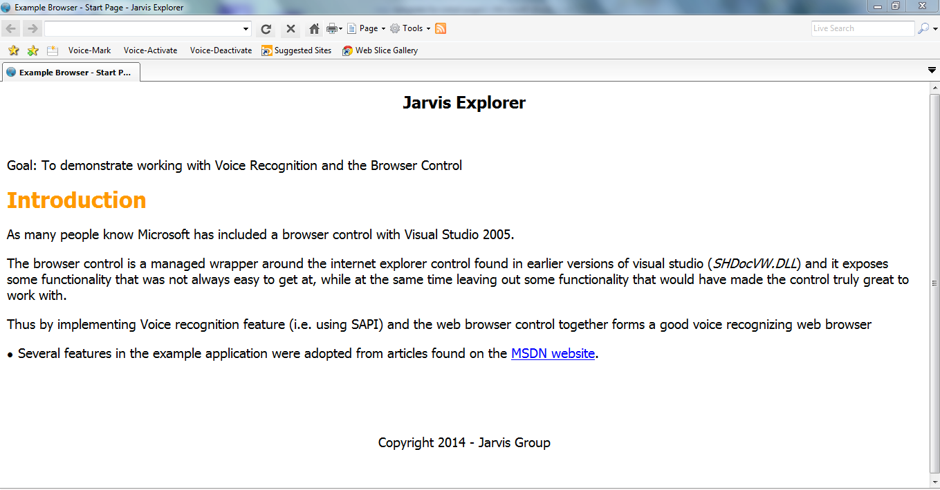

Fig 7.1 Main Browser window

8. TESTING
8.1 Test cases

Table 8.1 Test Case for attaching microphone and capturing video
Test case Title | To attach microphone and perform actions.
Description | Microphone is started correctly. Actions can be performed on web browser.
Expected Outcome | Successful voice recognition.
Result | Passed

Table 8.2 Test case for verification of voice recognition
Test case Title | To verify appropriate voice tasks.
Description | Use the microphone to give input voice where the spoken voice should perform web browser tasks.
Expected Outcome | Successful recognition of voice.
Result | Passed

8.2 Type of Testing Used
SYSTEM TESTING
Testing conducted on a complete, integrated system to evaluate the system's compliance with its specified requirements. System testing falls within the scope of black box testing, and as such, should require no knowledge of the inner design of the code or logic.

- CONCLUSION
Finger tracking is the main idea behind the implementation of pointer control using webcam. The report throws light on all the major aspects of finger tracking including the concept of hand detection, background subtraction, finger tip detection and finger point tracking. The various algorithms and flow charts to be used have been illustrated successfully.
People have been trying to use hands as an interface tocomputers. One of the ways to track hands robustly is to use motion to segmentand from the background.This can be done either by background subtraction or using optical flow to determine motion. We have use background subtraction method where we subtract two immediate clicks of same image and subtract them and if the difference is zero then it has something movable in it and that is hand.

10. FUTURE SCOPE

The variation in these figures makes the actual growth of the voice technology industry anyone's guess, especially as the big three handheld manufacturers (Ericsson, Motorola, and Nokia) have recently down-graded their sales predictions. Forrester Research is now forecasting alowly mobile retail revenue for 2005 in Europe at 5 billion Euros, exactly one percent of Lehman Brother's predictions of revenues of 500 billion Euros by 2005.
On the technology side, the future of voice browsing will be visual. Multi-Modal is the buzzword, naming the combination of voice direction and visual data. In the wireless world a phone is for two purposes: To relay data using sound and to relay data visually. Ignoring the visual or sound side of the phone is like amputating a leg and trying to run. Multi-modal is problematic however, getting the two legs to work together has been difficult. The multi-modal technology is not prevalent today for two reasons.

BIBLIOGRAPHY AND REFERENCES

[1] Er. Bhupinder singh “Speech Recognition as Emerging Revolutionary Technology”, 2012

[2] Afroza Sultana and Abdelwahab Hamou-Lhadj, An Improved Hidden Markov Model for Anomaly Detection Using Frequent Common Patterns,IEEE,2012

[3] IBM – www.ibm.in/developerworks.

[4] www.tutorialspoint.com/vb

[5] http://en.wikipedia.org/wiki/VB.NET (programming_language)

[6] www.stackoverflow.com

[7] Object Oriented Modeling and Design with UML-Michael Blaha, James Ram Baugh.
[8] Software Engineering, Seventh Edition, Ian Somerville.
[9] IBM Red Books.

